How to Shut down the project / Delete the project in Google Cloud Platform:

Login to your Google console at <https://console.cloud.google.com/>. Select 3 horizontal dots (.) which is available on the top right hand side and select PROJECT SETTINGS as shown in the below screenshot.

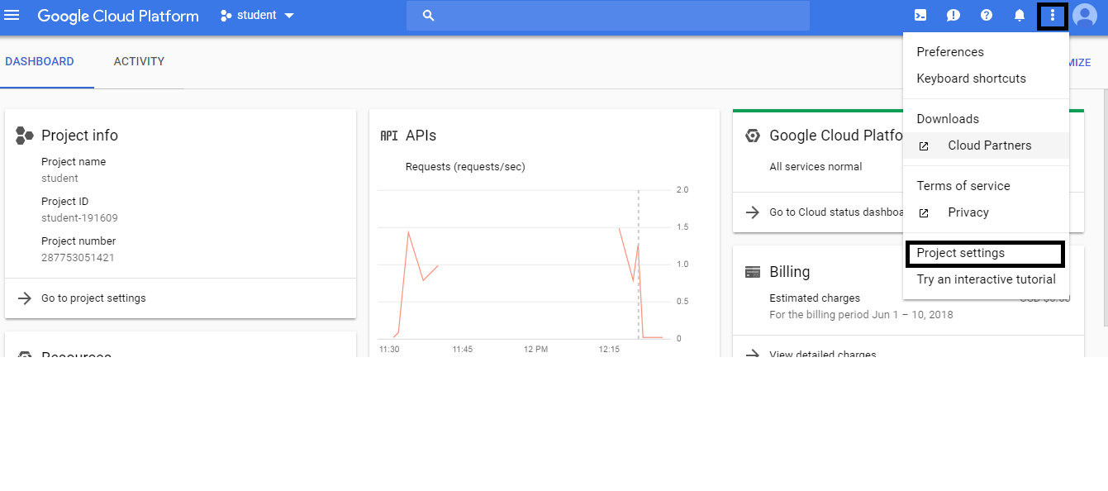

Click on SHUTDOWN (Trash icon) and enter the Project ID. Note that, project ID should be the complete name along with the numbers as highlighted in example screenshot. In the example screenshot, project Id is **student-191609**.

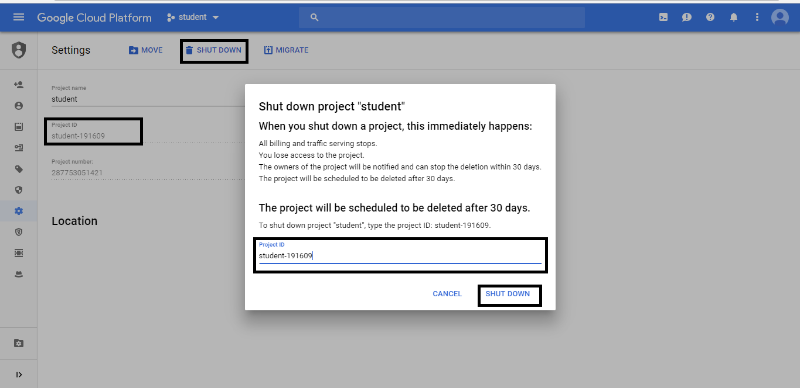

Once you click on SHUTDOWN in the dialog box, you should be able to see the confirmation that you’re project is scheduled to delete along with the date.